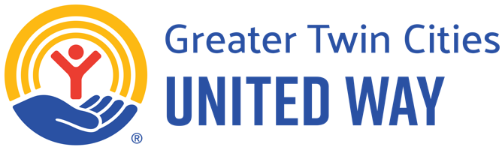
Month DD, YYYY
Subject Line: United is the Way! Announcing the 2025 [Your Company] Greater Twin Cities United Way campaign!
Dear [Employee Name],
At [Your Company], we believe a prosperous future belongs to everyone. And we’re all better off when we all have what we need to succeed. In 2024, you made it possible for Greater Twin Cities United Way to touch the lives of over half a million people in our region. Together, we:
- Responded to more than 241,000 requests via our 211 resource helpline from families struggling to pay for housing and put food on the table, parents seeking quality child care, young adults facing homelessness and more.
- Answered nearly 33,000 calls to the 988 Suicide and Crisis Lifeline, providing hope for a brighter tomorrow.
- Supported 170 local nonprofit partners in direct service, innovation and advocacy so that everyone in our region has access to healthy food, stable homes, educational success and economic opportunity. In addition to unrestricted and targeted funding, we provided over 200 hours of technical assistance to build nonprofits’ capacity.
- Successfully advocated for more than $50 million in funding for childhood literacy and pre-K programs, ensuring more young learners have support to succeed; increased funding for Minnesota’s Family Homeless Prevention and Assistance Program to help more families stay in their homes; $50 million in Housing Infrastructure Bonds to promote affordable housing; and improvements in college students’ eligibility for food assistance.

[Hold for any company match details]
[Hold for any virtual events or company incentives]
Thank you for joining us in this work by volunteering, giving and advocating for a community where all people thrive!
Thank you on behalf [Company Name] and Greater Twin Cities United Way,
[CEO or Executive Sponsor Signature]

Month DD, YYYY
Subject Line: United is the Way with [Your Company] & Greater Twin Cities United Way campaign!
Dear [Employee Name],
Greater Twin Cities United Way is a persistent presence in our community. Because of your support, in 2024, we were here for each other, every minute of every day:
- Every three hours, a parent found high-quality childcare in their community, supported by Greater Twin Cities United Way.
- Every 35 minutes, a youth or adult experiencing homelessness secured shelter and support from a Greater Twin Cities United Way partner invested in their success.
- Every 19 minutes, a youth or adult started their career path with education, job training or entrepreneurship services from a Greater Twin Cities United Way partner who understands their individual strengths.
- Every 16 minutes, a caller to the 988 Suicide and Crisis Lifeline connected with a Greater Twin Cities United Way crisis counselor to find hope for a brighter tomorrow.
- Every two minutes, a 211 resource specialist helped a neighbor in the Greater Twin Cities find shelter, food, quality child care and more.
- Once a minute, a neighbor facing hunger got groceries or a hot meal from a Greater Twin Cities United Way partner who cares about them.
[Hold for any company match details]
[Hold for any virtual events or company incentives]
Thank you on behalf of [Company Name] and Greater Twin Cities United Way,
[CEO or Executive Sponsor Signature]

Month DD, YYYY
Subject Line: United is the Way! Closing out the 2025 [Your Company] Employee Giving Campaign
Dear [Employee Name],
Thank you for being a part of this year’s campaign.
Greater Twin Cities United Way is unique because we meet urgent community needs in housing, food, education and jobs while making lasting change to end persistent inequities so all can thrive. Our work is responsive to evolving community strengths and needs, and our impact is lasting, because we cultivate longstanding partnerships with communities, employers, policy makers and supporters.

Your personal approach to giving is an important part of a unified movement
  - Donate financially through your workplace.
  - Volunteer for a project you’re passionate about.
  - Advocate by championing the voices of our neighbors.
Greater Twin Cities United Way’s mission is to unite changemakers, advocate for social good and develop solutions to the challenges no one can solve alone. Our vision is a community where all people thrive regardless of income, race or place.

[Hold for any company match details]
[Hold for any virtual events or company incentives]
Together, we will create a community where all people thrive regardless of income, race or place.
Thank you on behalf of [Company Name] and Greater Twin Cities United Way,
[CEO or Executive Sponsor Signature]

