Thank You!
FOR MAKING A LIFE-CHANGING DIFFERENCE IN THE GREATER TWIN CITIES.

Company Name

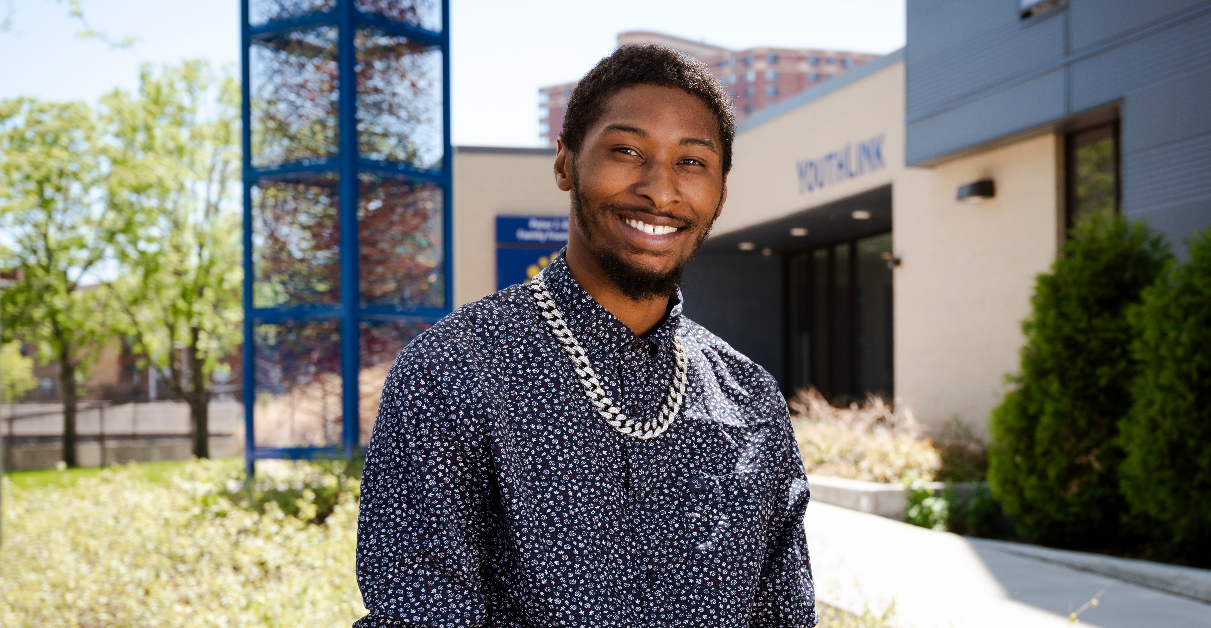Recipient Name
Unite Chtoafunelge

